Pupils Attitude to Self and School
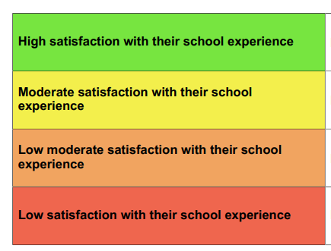
KS2
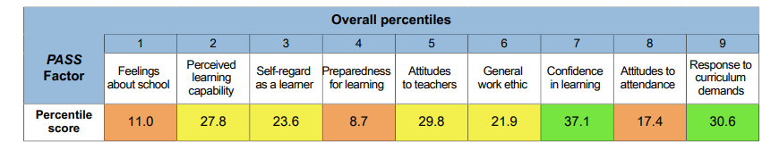
KS3
